http://beforeitsnews.com/story/1091/566/NASA_Whistleblower:_Alien_Moon_Cities_Exist.html

NASA Whistleblower: Alien Moon Cities Exist
Tuesday, September 13, 2011 11:52
share this story
3423Share
110
7
inShare

Former National Aeronautics and Space Administration Data and Photo Control Department manager, Ken Johnston, who worked for the space agency's Lunar Receiving Laboratory during the Apollo missions has been fired for telling the truth.
Johnston asserts NASA knows astronauts discovered ancient alien cities and the remains of amazingly advanced machinery on the Moon. Some of the technology can manipulate gravity.
He says the agency ordered a cover-up and forced him to participate in it.
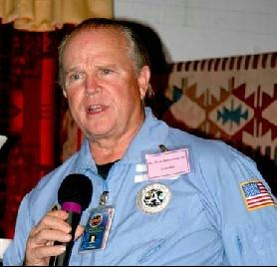
Ken Johnston in happier days at JPL
Over the past 40 years other scientists, engineers and technicians have accused NASA of cover-ups and obscuring data.
The growing number of accusers' allegations range from hiding information about anomalous space objects and lying about the discovery of artifacts on the surface of the Moon and Mars, to denying the evidence of life reported back by the Viking lander during the mid-1970s.
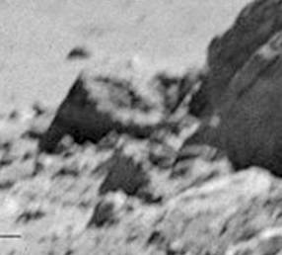
Strange object photographed by Apollo astronauts
According to Johnston, Apollo astronauts brought back photographic evidence of the artifacts they found during their lunar extravehicular activities (EVAs). Johnston claims NASA ordered him to destroy the EVA images while he was at the Jet Propulsion Laboratory (JPL), but he refused.
When he went public, the space agency terminated him.

Kay Ferrari, JPL Director of the SSA program
In a news release, Kay Ferrari, the JPL Director of the SSA Program, explained why she asked Johnston to resign: he had publicly criticized his employer.
When Johnston refused to tender his resignation, he was summarily dismissed without cause.
After his abrupt departure, he indicated he'd had enough and was tired that the U.S. government had been sitting on the proof for more than four decades that ancient alien cities are the Moon.
“I have nothing to lose," he said. "I quarreled with NASA and I got fired."
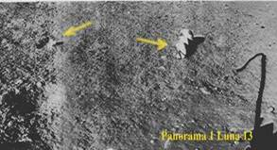
Russian Lunik 13 photo of artificial, maufactured object
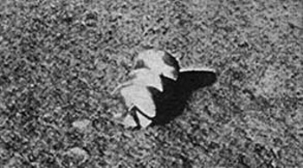
Lunik 13 enlarged photo of manufactured artifact
Evidence has emerged of large structures, perhaps even a base on the far side if the Moon, that seems to support Johnston's allegations. See Before It's News article "Claim: Secret American Base Discovered on Moon."
Space scientist livid over NASA cover-up
Ken Johnston isn't the only one to have a bone to pick with NASA.
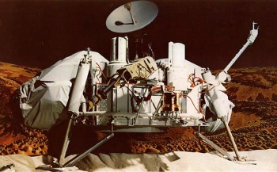
Viking discovered life on Mars - Gilbert Levin
The scientist who oversaw the important life-detection experiment aboard the 1976 Viking space probe mission on Mars continues to blast the U.S. space agency.
Gilbert Levin insists his biology experiment proved life is in the Martian soil.
"We obtained positive data corresponding with all the pre-mission criteria, which proved the existence of microbial life in the soil of Mars," Levin told National Geographic. ["I Found Life on Mars in 1976, Scientist Says"]
The prominent scientist is so angry at NASA he's even created his own website designed to shout to the world that life really is on the Red Planet.
The color of deception
Many space scientists have challenged NASA about yet another fraud the agency allegedly perpetrated for decades: the color of the Martian sky.
For years the space agency released photos of Mars with a reddish tinged sky and rusty red landscape. They got away with it too until independent researchers and Mars missions undertaken by the European Space Agency (ESA) revealed that the Martian sky actually looked very similar to Earth's sky--and the Martian landscape pretty much resembled the pale salmon colored terrain of the American Southwest.
Holger Isenberg has written about it on the German site "The Color of Mars." Here's a translated link with the photographic evidence.
More controversy over photos
Former NASA employee, Donna Hare, has accused NASA of doctoring, obfuscating, and obscuring thousands of photos over the years. She has gone on record alleging the space agency erased inconvenient anomalies on certain damning photos.
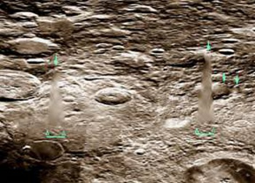
Image purposefully smudged
During her time at NASA she was a specialist working as an illustrator and photographic slide technician. Her service awards include the 1969 Apollo Achievement award, a Skylab award, and a special commemorative medallion for meritorious service involving the joint American-Russian space mission, Apollo-Soyuz.
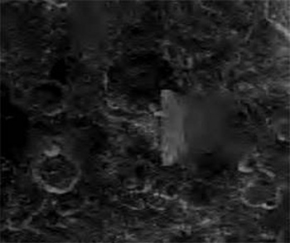
What doesn't NASA want you to see?
A technical illustrator by profession, Hare has just about done it all during her tenure with the space agency, working as a space illustrator and in the Precision Slide Lab. She illustrated space vehicles, satellites, launch pads, landing sites, lunar maps and much, much more.
Hare worked as a sub-contractor with the agency for more than 15 years. When she blew the whistle on NASA, she went public and appeared as a guest on WOL-AM radio in Washington, D.C.
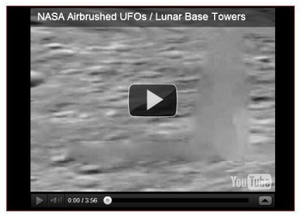
This Youtube video exposing NASA image tampering was ordered removed by NASA
Her testimony is controversial and some support her contentions while others do not.
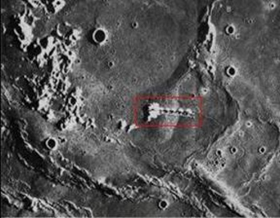
Did NASA miss smudging this photo?

Enlargement of photo? Artificial? What do you think?
Apollo 17 and the astonishing 'robot head'
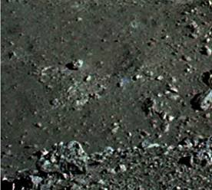
"In December of 1972 Apollo 17 astronauts Eugene Cernan and Harrison Schmitt spent about 75 hours on the Moon. During their lunar expedition they took the photo seen above. As incredible as it sounds it appears to be the severed head of a robot. As Cernan put it, even though he was seeing it with his own eyes, he still couldn't quite bring himself to believe it," writes author Joe Szostak in his book and website.
"After overcoming his initial shock he realized that it couldn't be a human skull. After all, it was lying in a debris field from an impact crater, which had tossed up all manner of junk and material from just below the valley floor. Something as fragile as a fossilized bone could not possibly survive such an impact.
"Furthermore, exposure to extreme solar and cosmic radiation would have long since reduced organic material to a fine powder. This object was unmistakably of mechanical origin. Color enhancements showed that the 'head' had a distinctive red stripe around the area where the upper lip should be, a feature that clearly appeared to be painted or anodized on the object.
"Composites of other frames showed that the 'head' had two eye-sockets, a forehead, brow ridges, a nose with nostrils, twin cheek bones and the upper half of the jaw. The lower jaw seemed to be missing.
"Cernan dubbed the area 'one mysterious looking place.' Many of the rocks had highly unusual spectral qualities, reflecting light more like crystals or highly polished metallic boxes.
"The bottom photo is an enlargement of the severed head photographed in Shorty Crater by Cernan and Schmitt. To this day there hasn't been a satisfactory explanation for this artifact from the scientific community..."
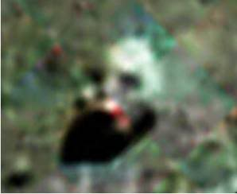
Lunar artifact is obviously not natural
The incredible Hubble photo of perfect pyramid on the moon
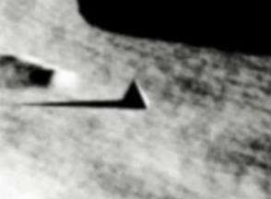
Who built this? When" Why?
The image of this pyramid on the Moon was taken by the Hubble Space Telescope (HST) in December 2008.
The Aristarchus Crater complex
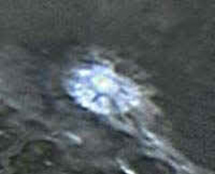
Look closely. Is this really a 'crater?'
"The Aristarchus Crater enigma is one of numerous so-called transient lunar phenomena (TLP). It is the brightest spot on the Moon as seen from Earth, which changes color, sometimes producing a red or bluish glow, and appears to emit gas. In 1958 Aristarchus Crater's strange phenomena were observed by Russian astronomer Nikolai Kozyrev. They were also reported by the crew of Apollo 11.
"The nature of the crater phenomena has given credence to a theory that there could be some sort of a power device, possibly a fusion reactor, in the crater. On any photo published by NASA except for a Clementine image this object is shown as a bright white smudge with no definition [Emphasis added]. This structure appears to be supported by 5 or 6 arches. In the foreground is a road that leads to a brightly lit tunnel entrance." [Joe Szostak]
Russian Luna 9 photographs space vehicle
"Luna 9 was an unmanned space probe of the Soviet Union's Luna program. On February 3, 1966 Luna 9 became the first spacecraft to achieve a soft landing on any planetary body other than Earth and to transmit photographic data back to Earth from the Moon. [The] photo is from the Luna 9 probe. It shows what appears to be a large craft or vehicle whose shape resembles that of an ocean going ship on Earth, coming to a point at one end and having an elevated section on top. A cable or tube appears to extend from the rear of the object toward the surface. Contact with Luna 9 was lost on February 6, 1966 just three days after landing." [Joe Szostak]
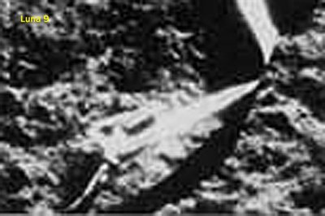
Odd things are on the Moon and Mars. Strange things have been found on the Martian moon Phobos, Saturn's moon Titan, and a handful of other more obscure moons.
The evidence seems to be mounting that we were not always alone in the Solar System. In fact the place seemed downright crowded.
Maybe it still is...

